CyberLab Setup

Environment Setup:

The lab environment was built using two virtual machines (VMs):

* **Suspect Machine:** Windows 10 VM simulated with compromised files
* **Investigator Machine(Attacker):** Kali Linux VM equipped with alot of tools

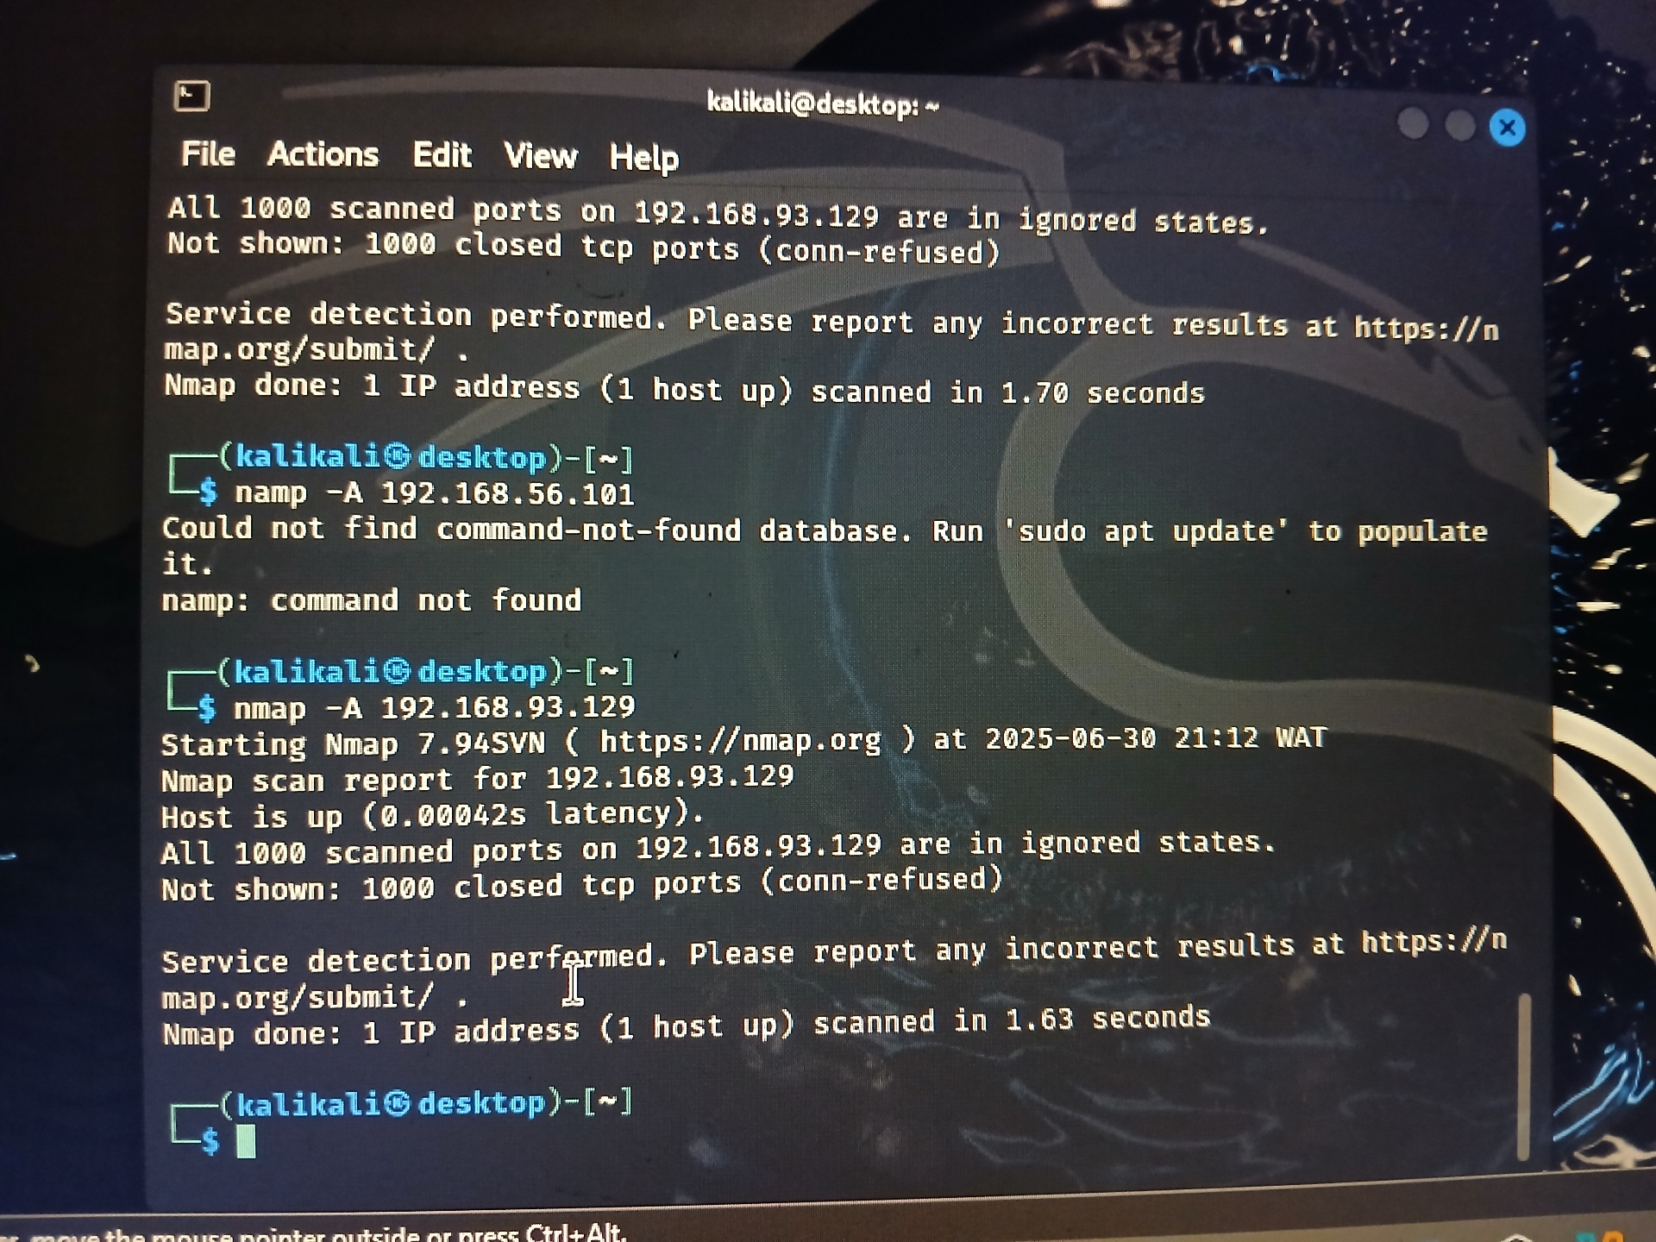

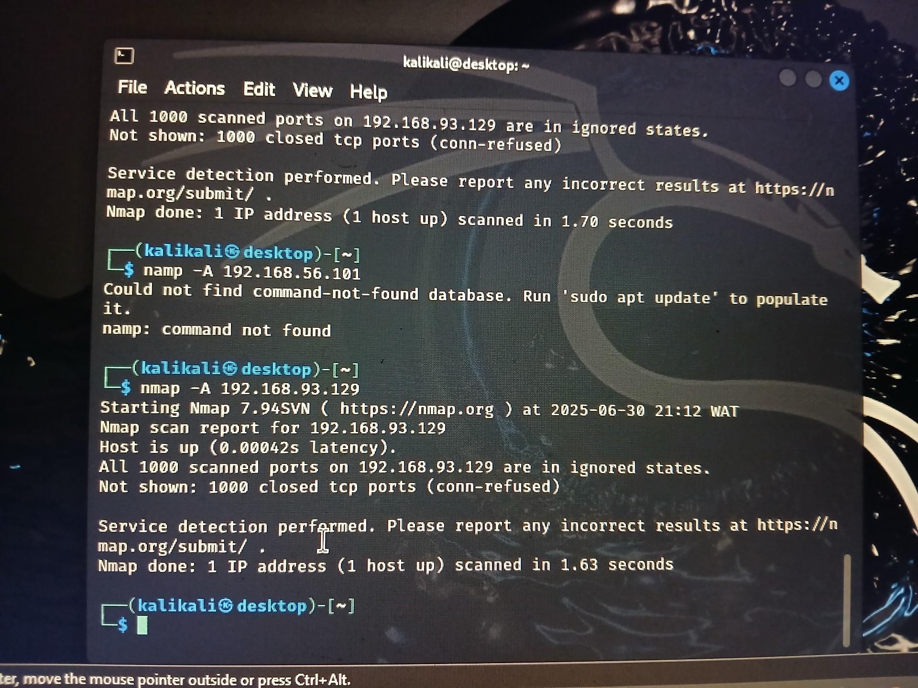

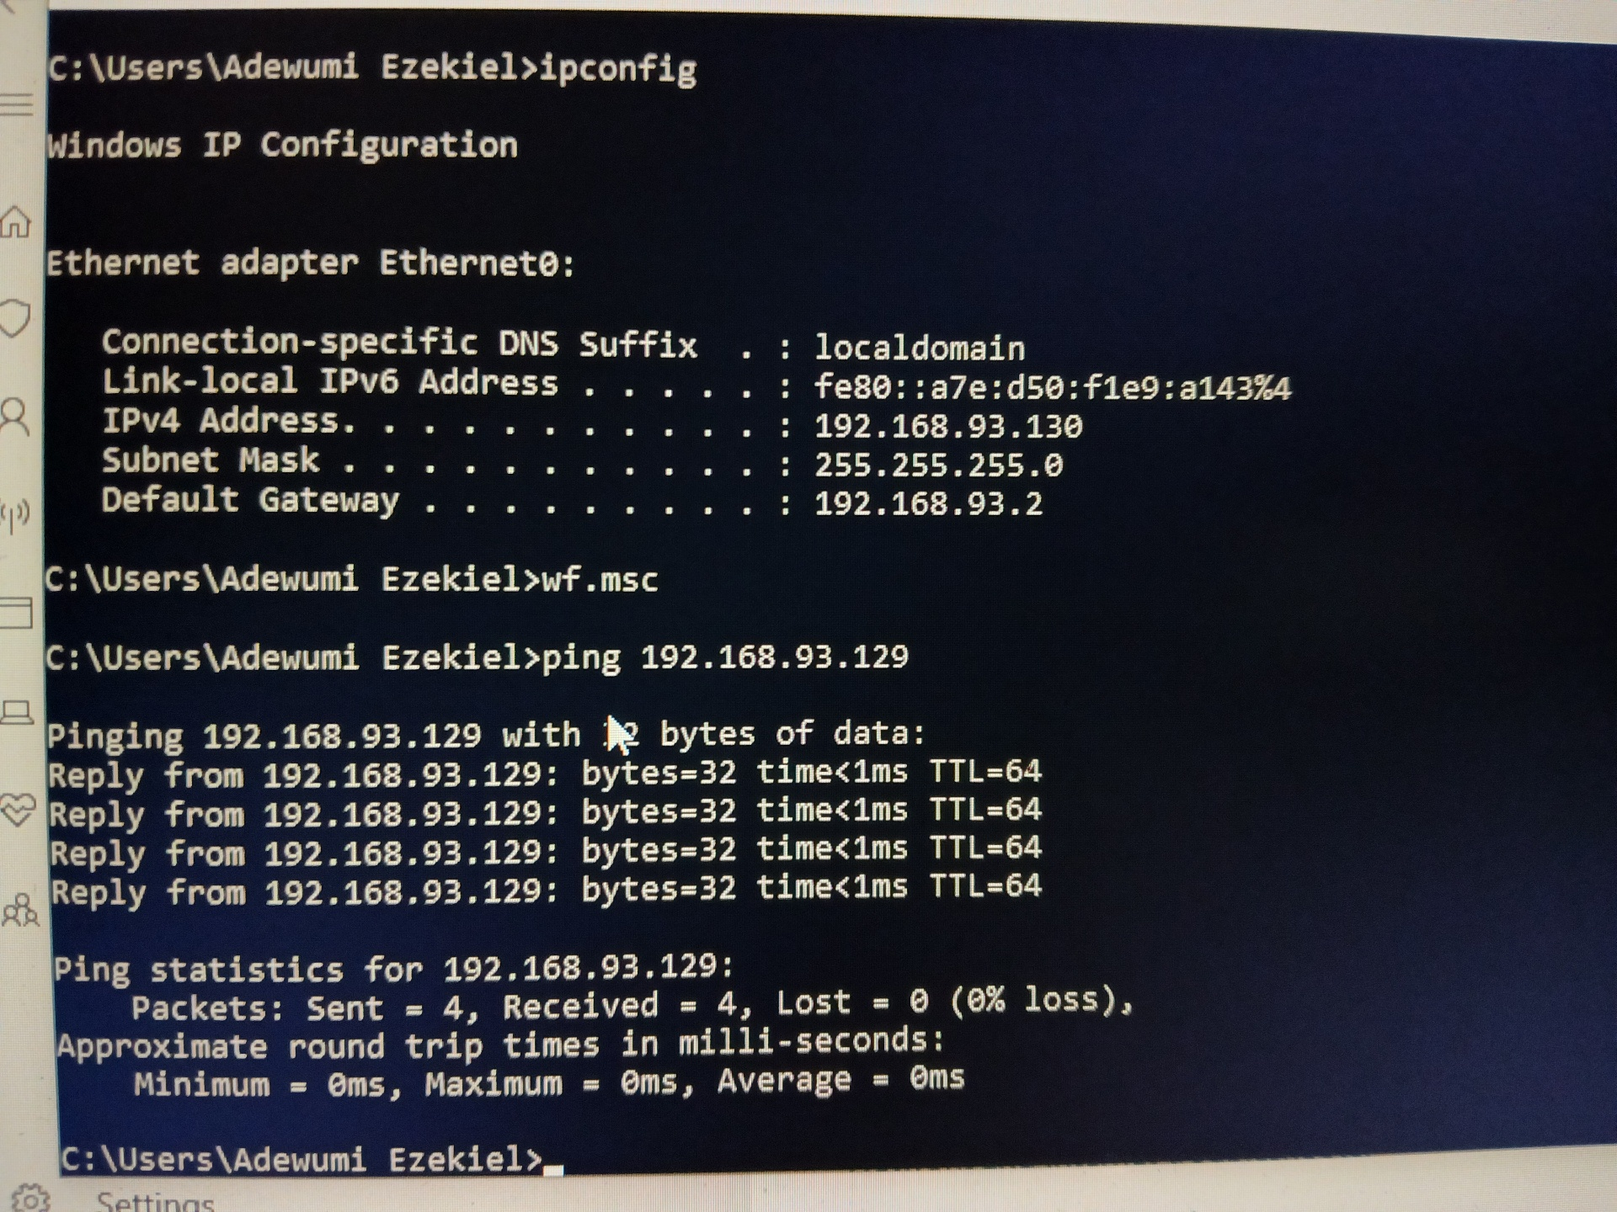

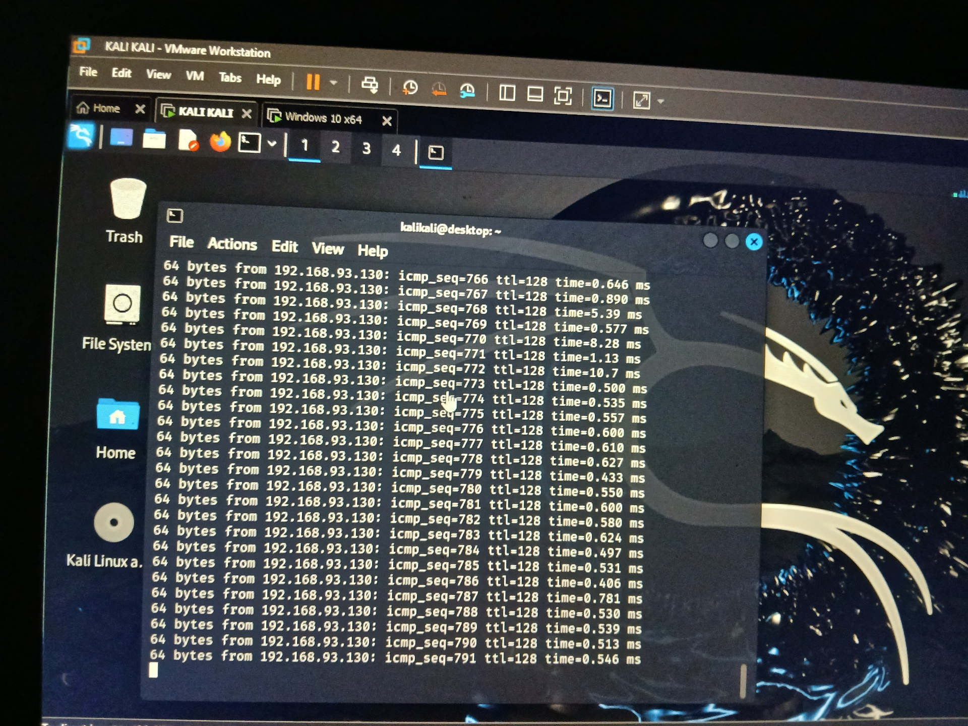

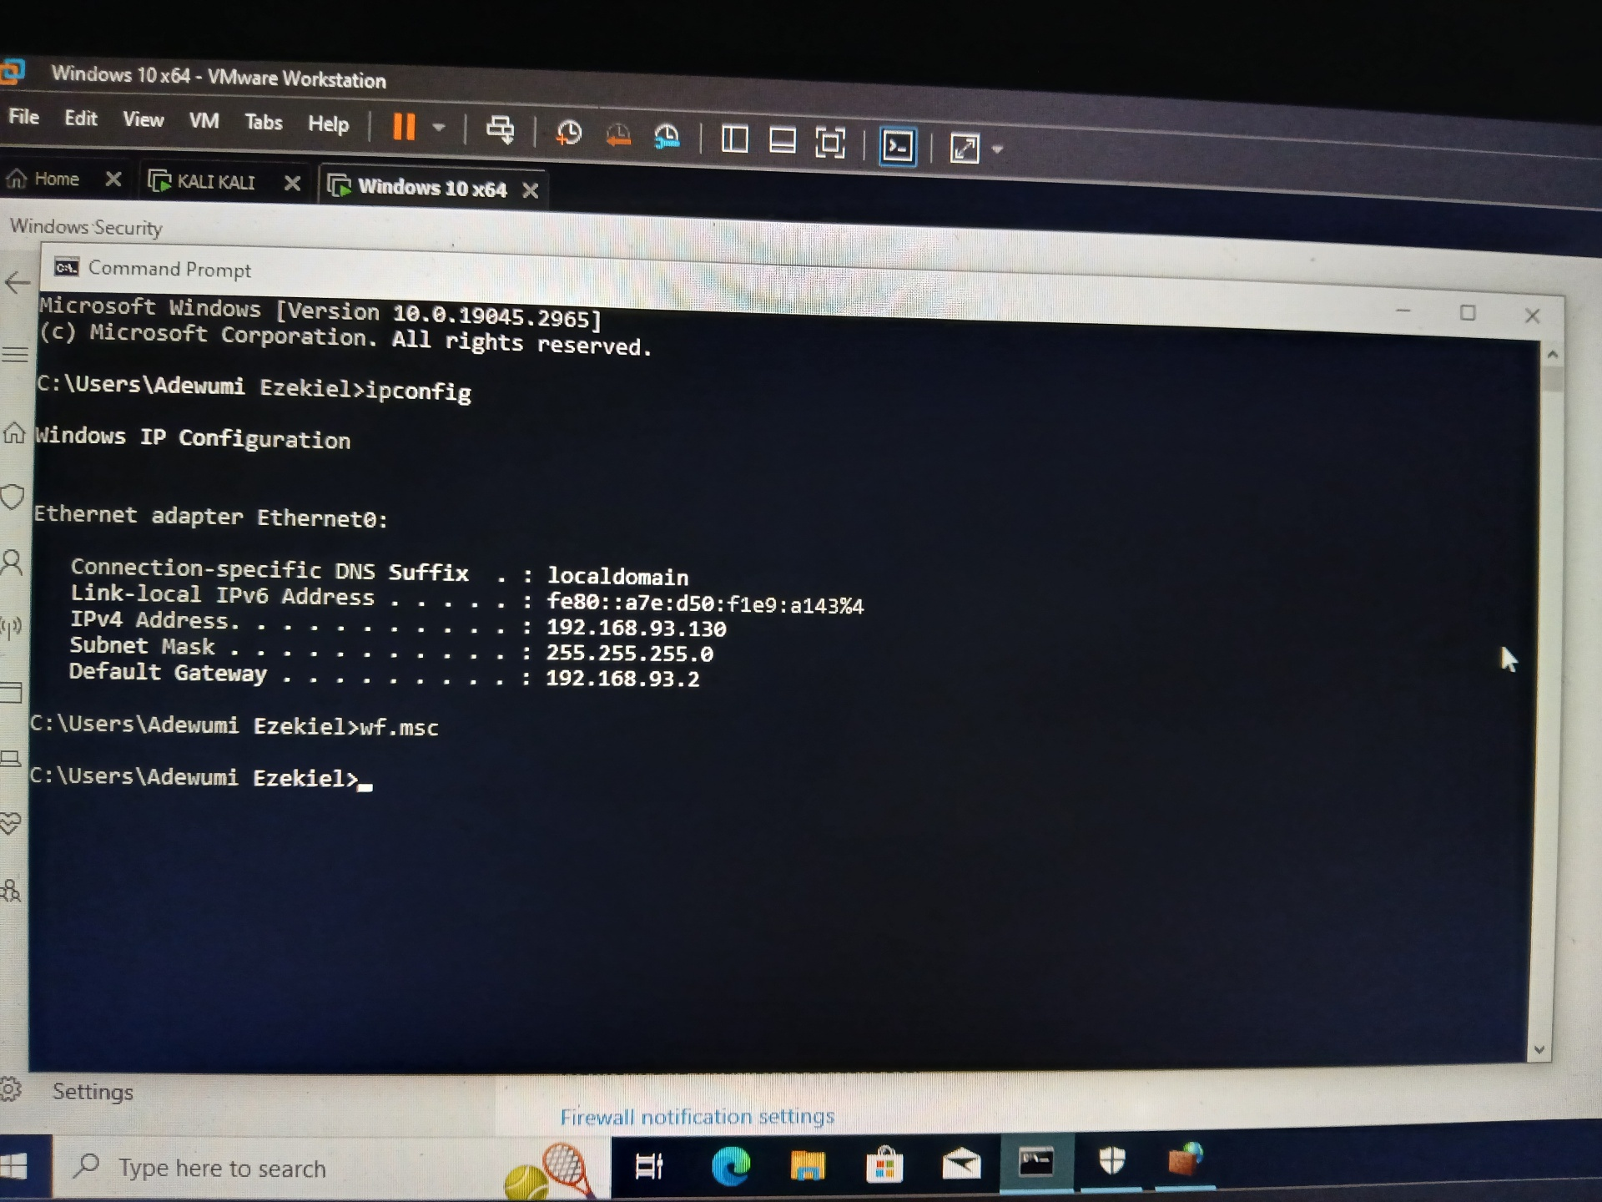

Extraction

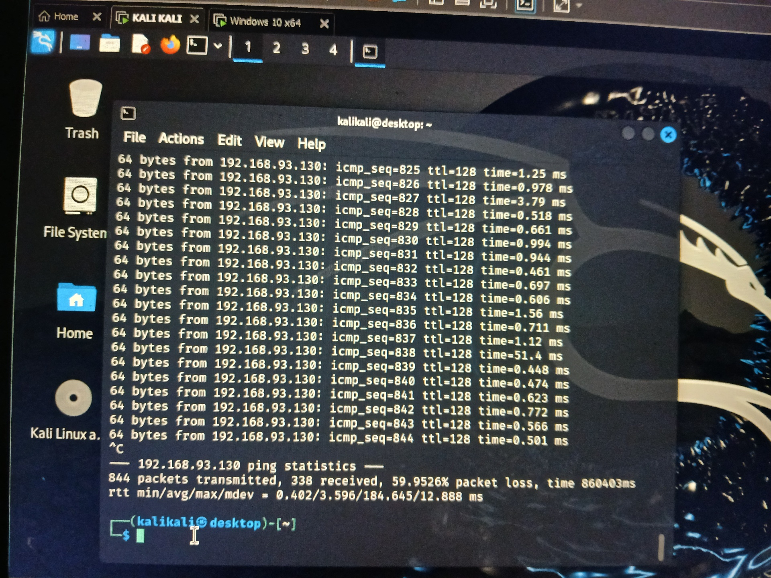

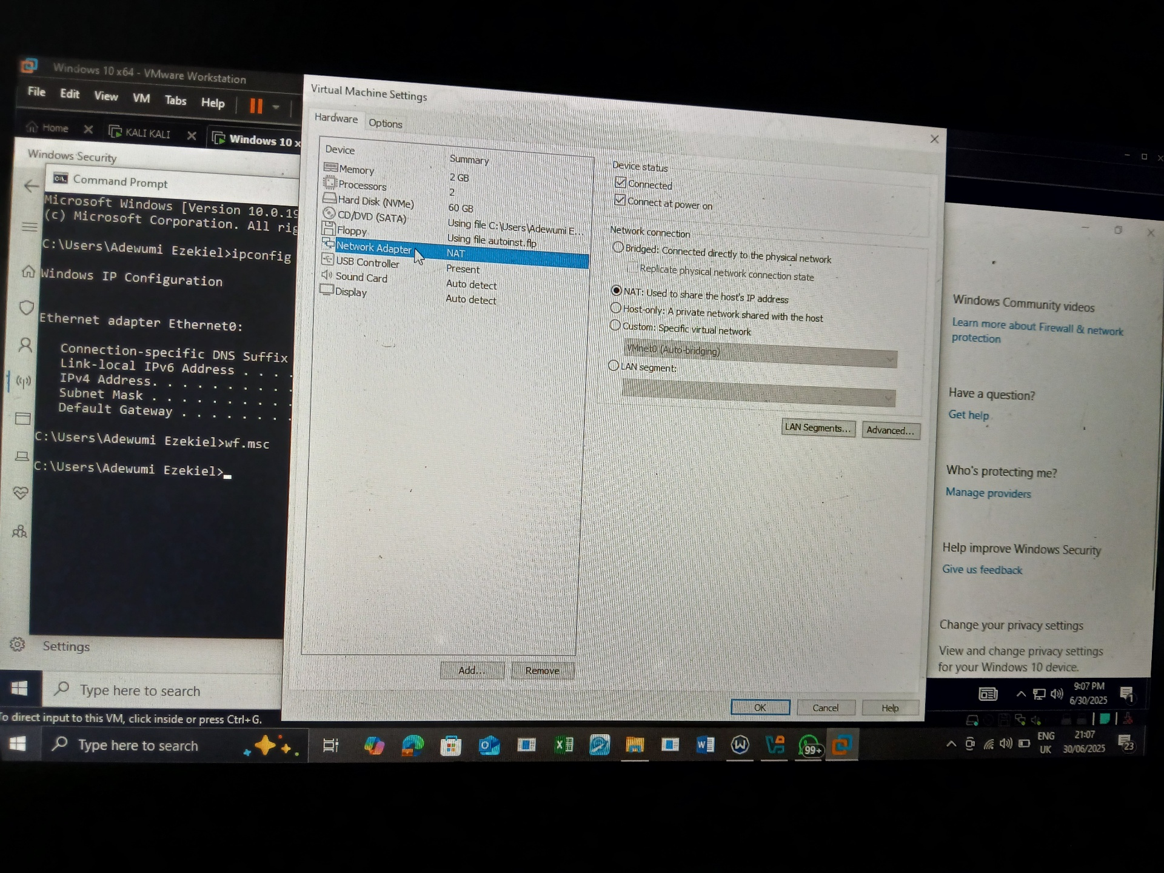

Network Connectivity and Service Enumeration:

I verify that communication existed between the virtual machines on the same

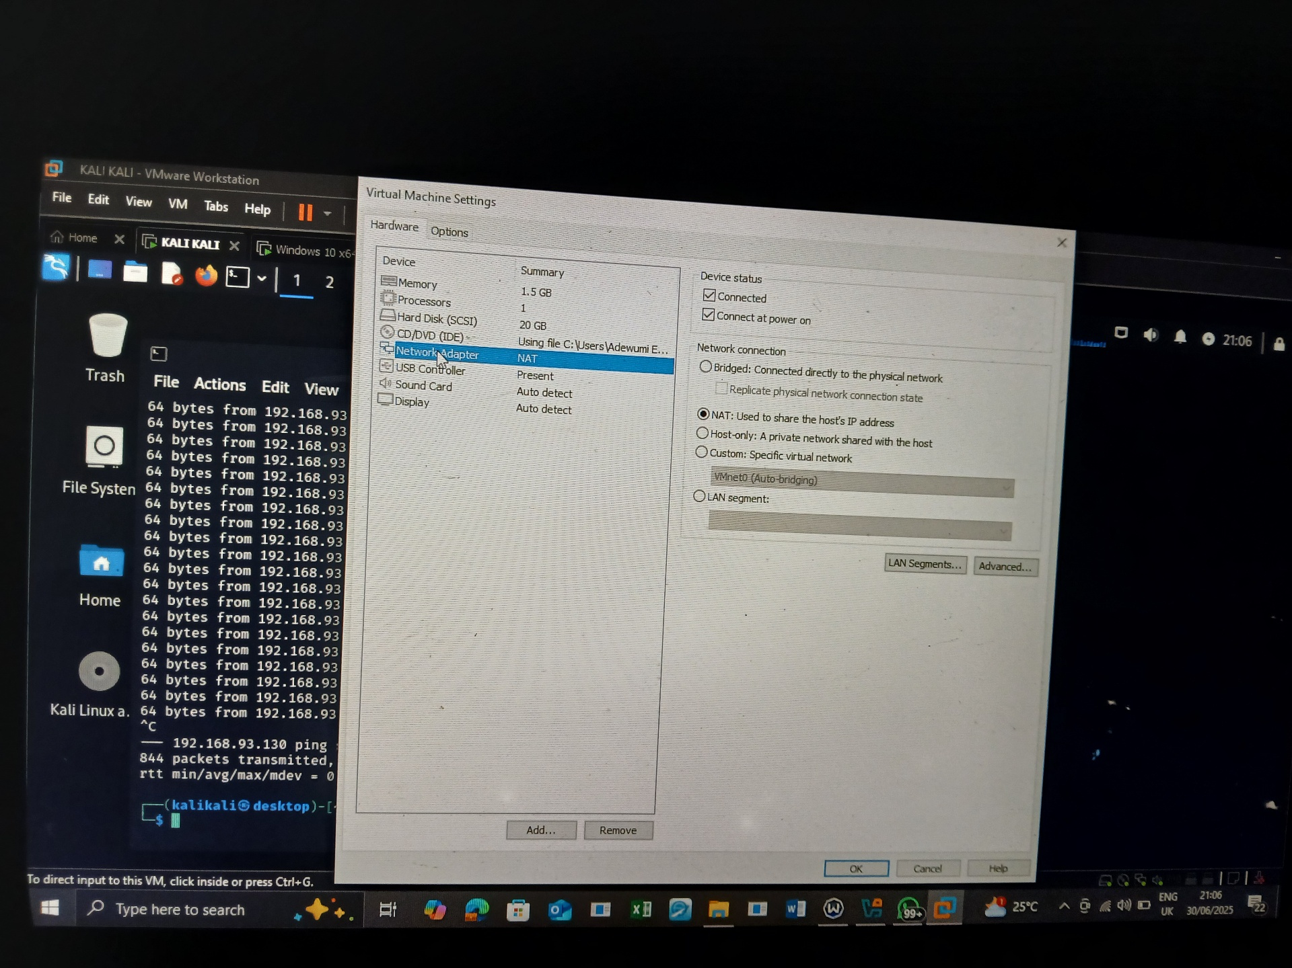

network, I performed a basic connectivity test using the **ping** command.

**Procedure:**

* I opened the terminal on my Kali Linux VM attacker.
* I pinged the IP address of the target (Windows) VM using the command.
* The response showed **successful ICMP replies**, confirming that both systems were on the same network and could communicate.

Port Scanning and Service Enumeration (Nmap)

I carried out some commands to identify which ports were open and what services were running on the target machine, I used **Nmap**, a powerful network scanning tool. All ports were closed from my analysis

**Procedure:**

* From my Kali Linux VM, I ran the following Nmap command

Nmap -sV (target ip address)

Forensic Analysis and Evidence Extraction from Compromised System

Toolset Used

**Autopsy** – For GUI-based analysis of disk image and evidence extraction

Android Analyzer (Autopsy Module)- This tool is useful in mobile forensic investigations to gain insights into user behavior and communication patterns.

Android Analyzer (aLEAPP)-a specialized forensic tool created by Alexis Brignoni. It enhances Autopsy’s capabilities by parsing additional Android artifacts.

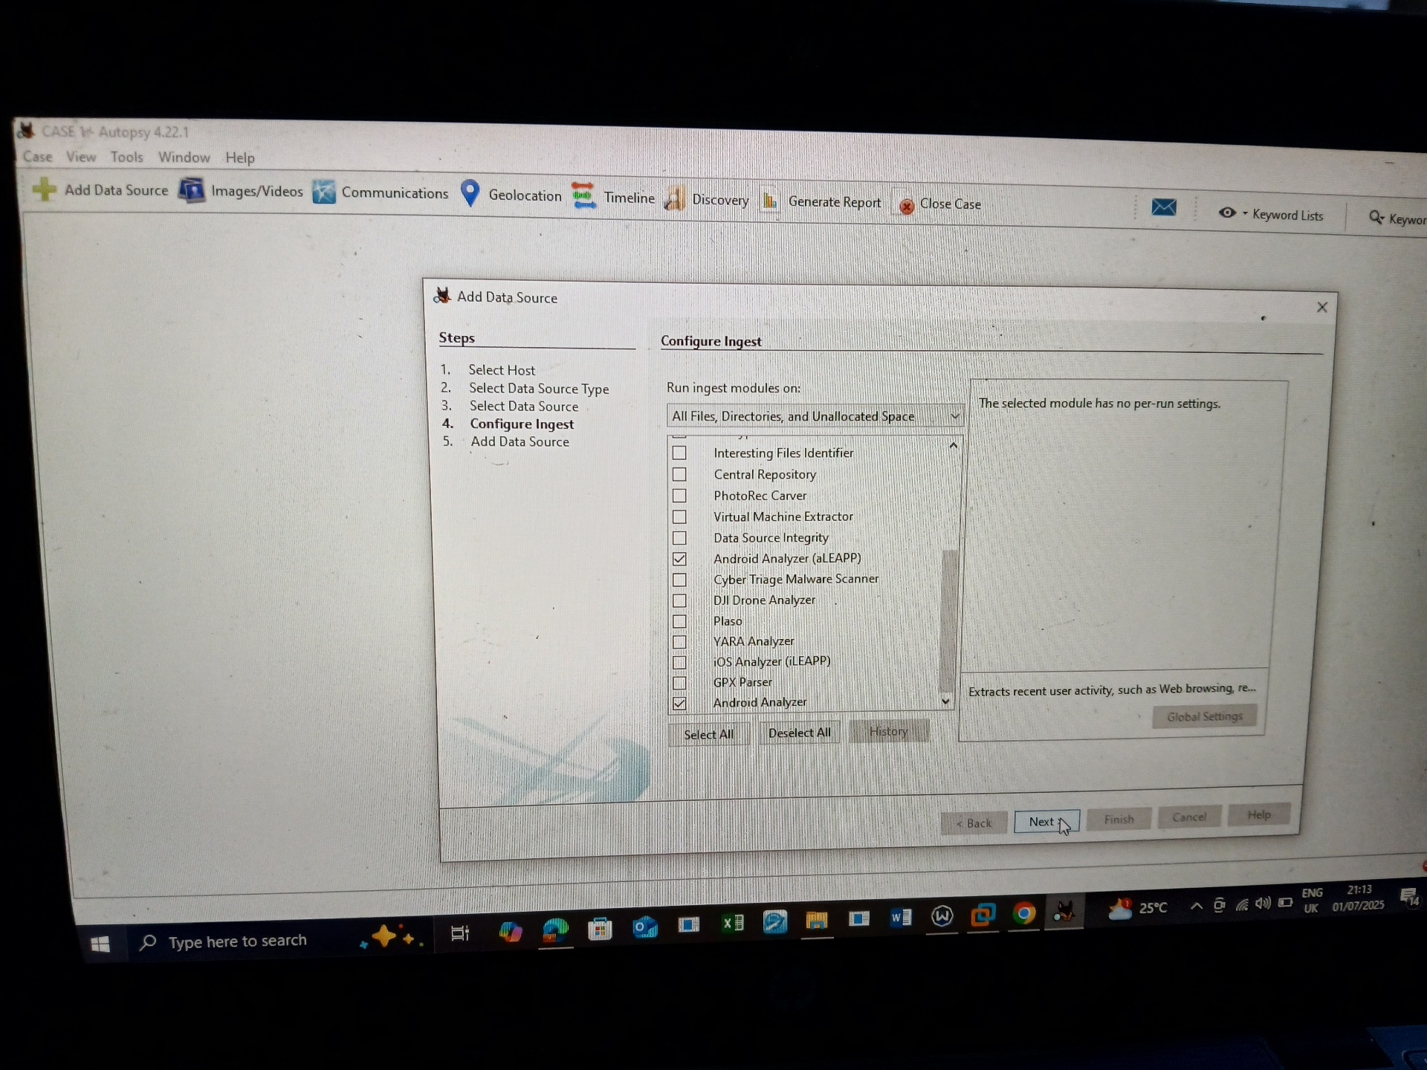

Analysis Methodology

Acquisition- The target android image was analyzed by the android analyzer and android analyzer (aLEAPP) to gain more insight on communication patterns

Verification- Analysis and confirmation of data

Examination- Autopsy was used to scan the android image for patterns communications

Extraction- evidence artifacts such as suspicious contact, messages and browser history were screenshoted

Documentation- my findings were recorded with screenshot

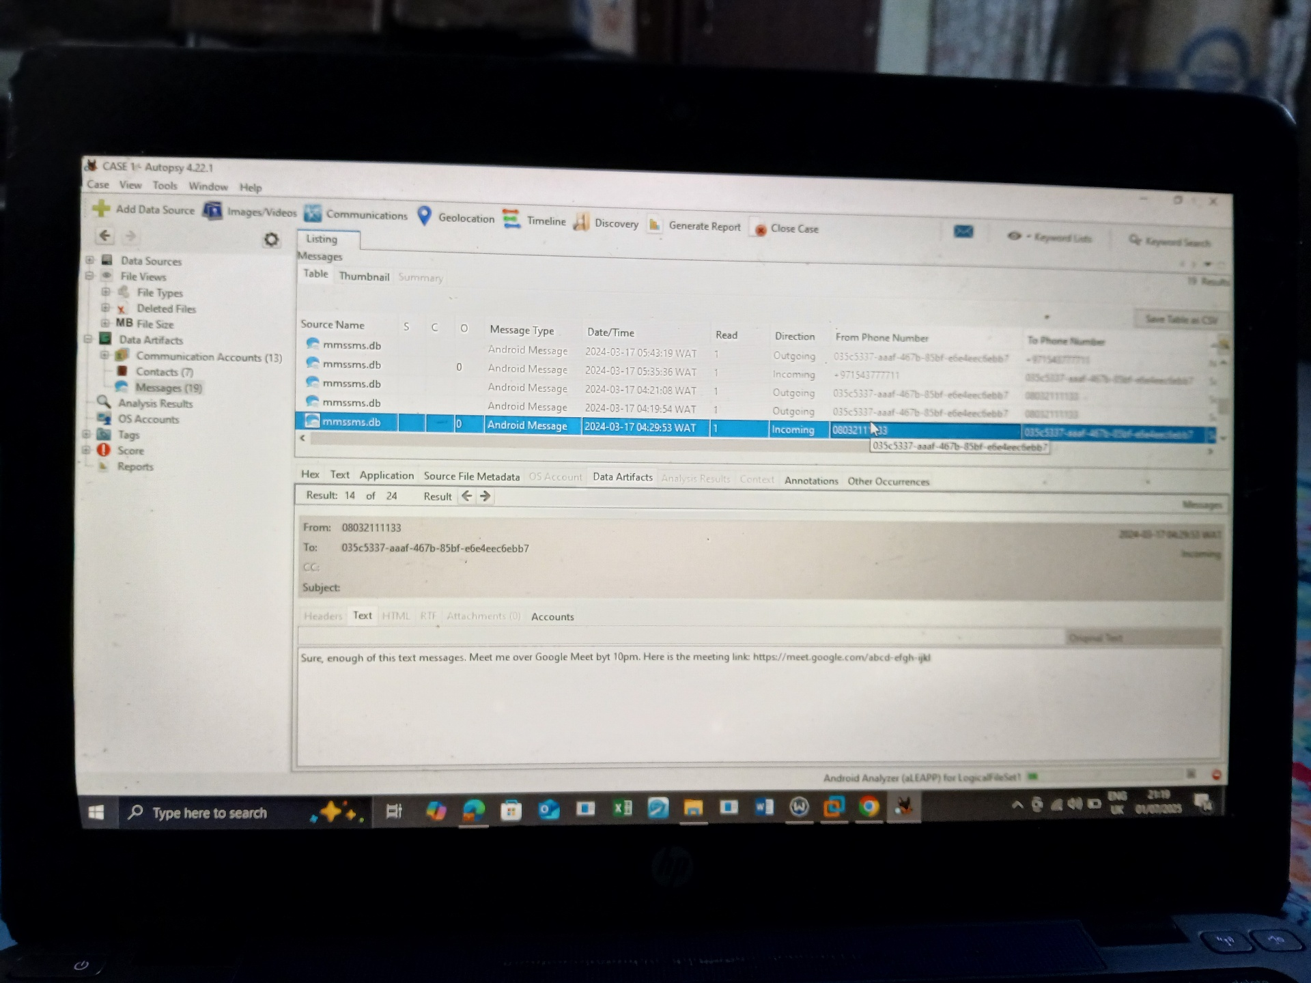

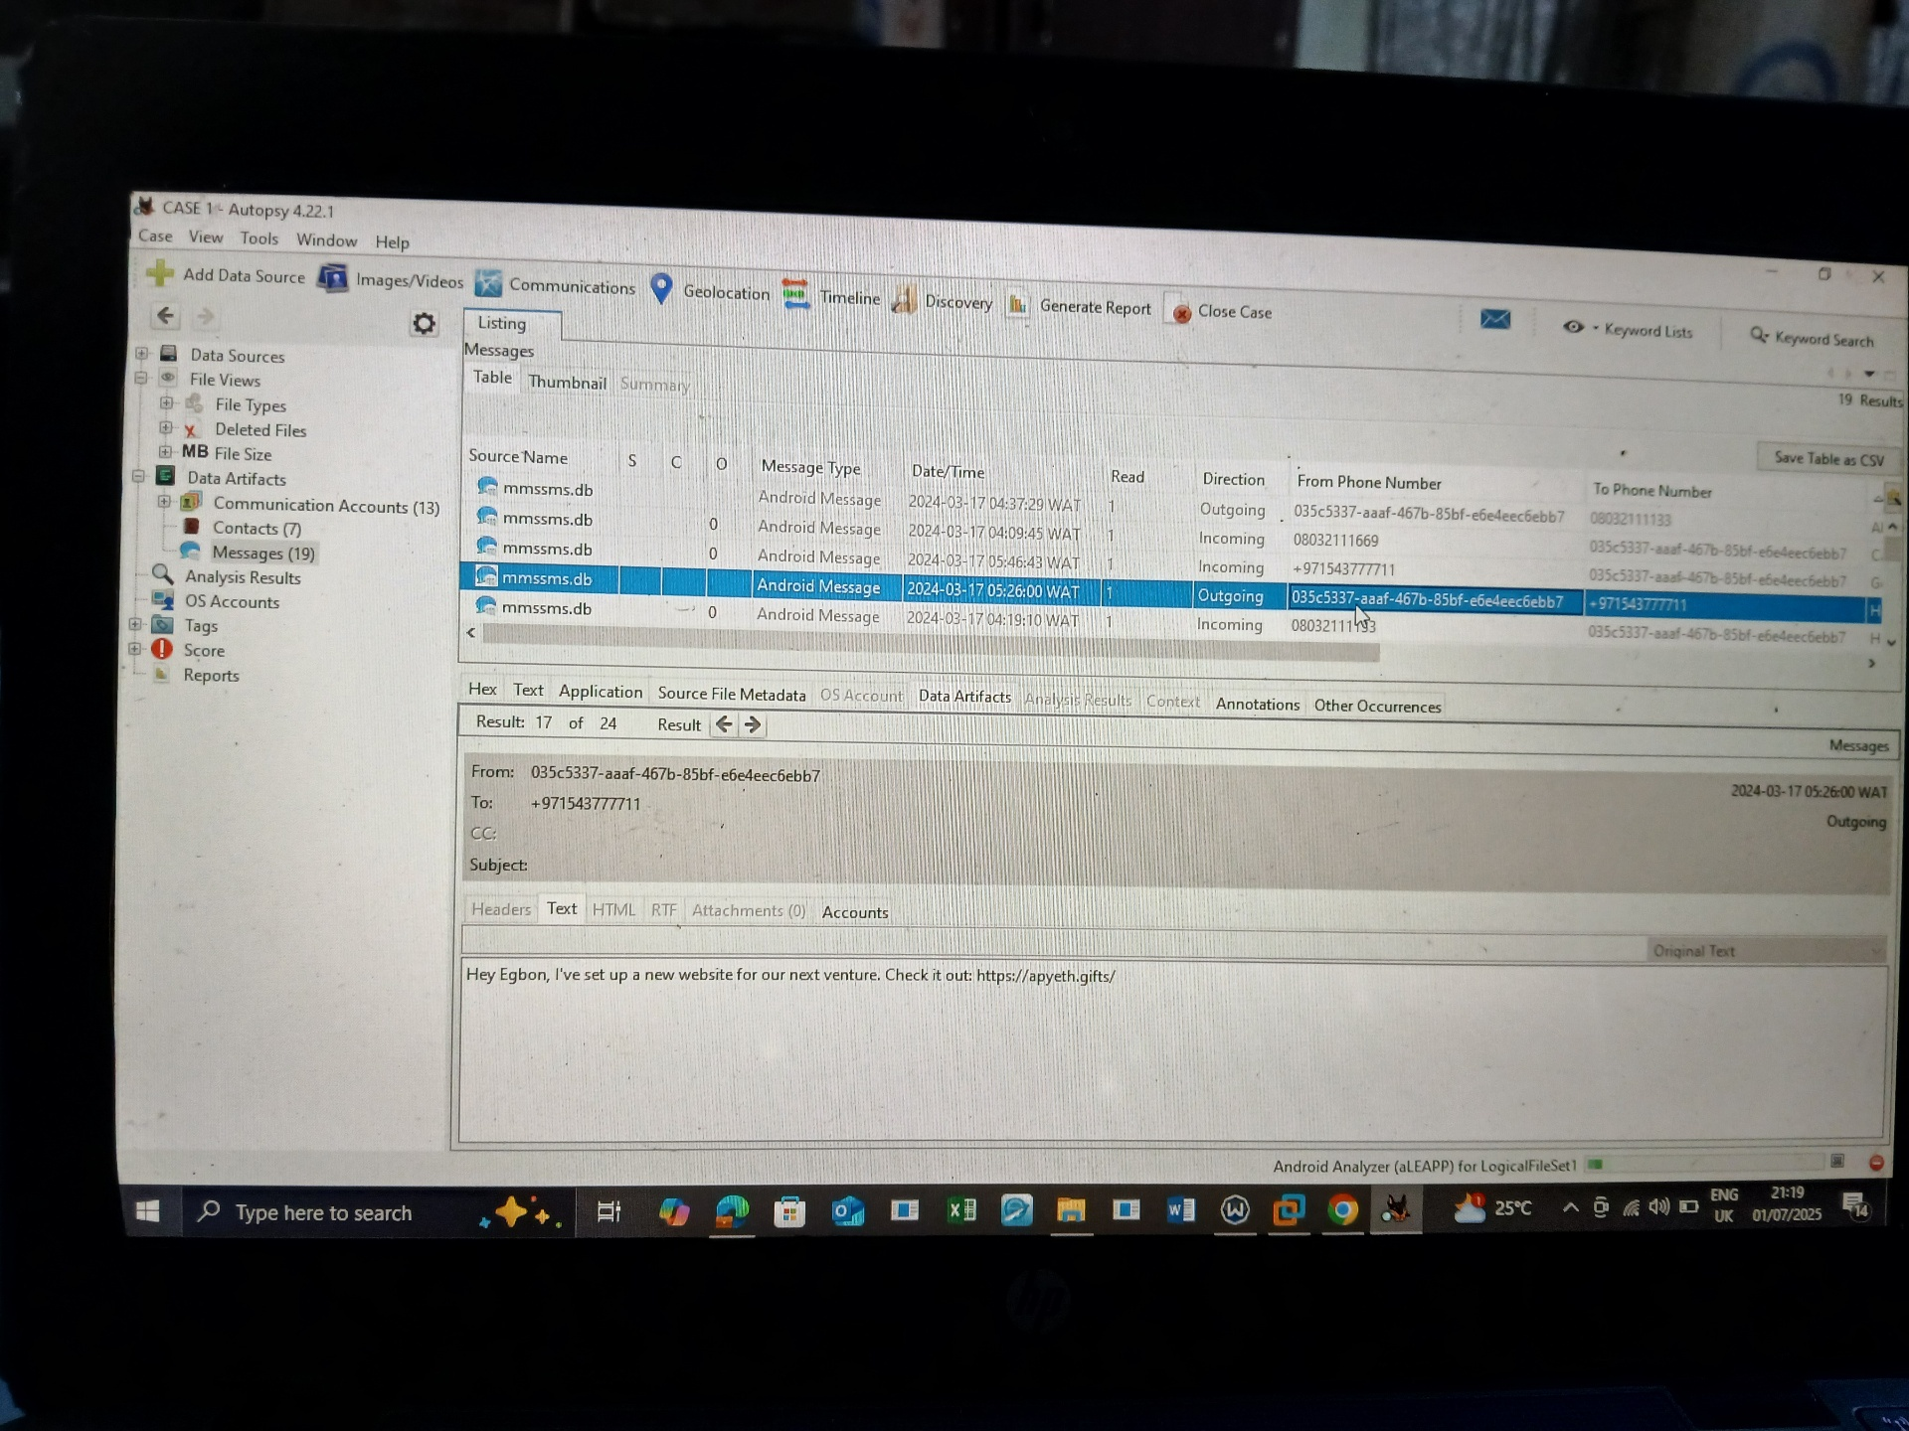

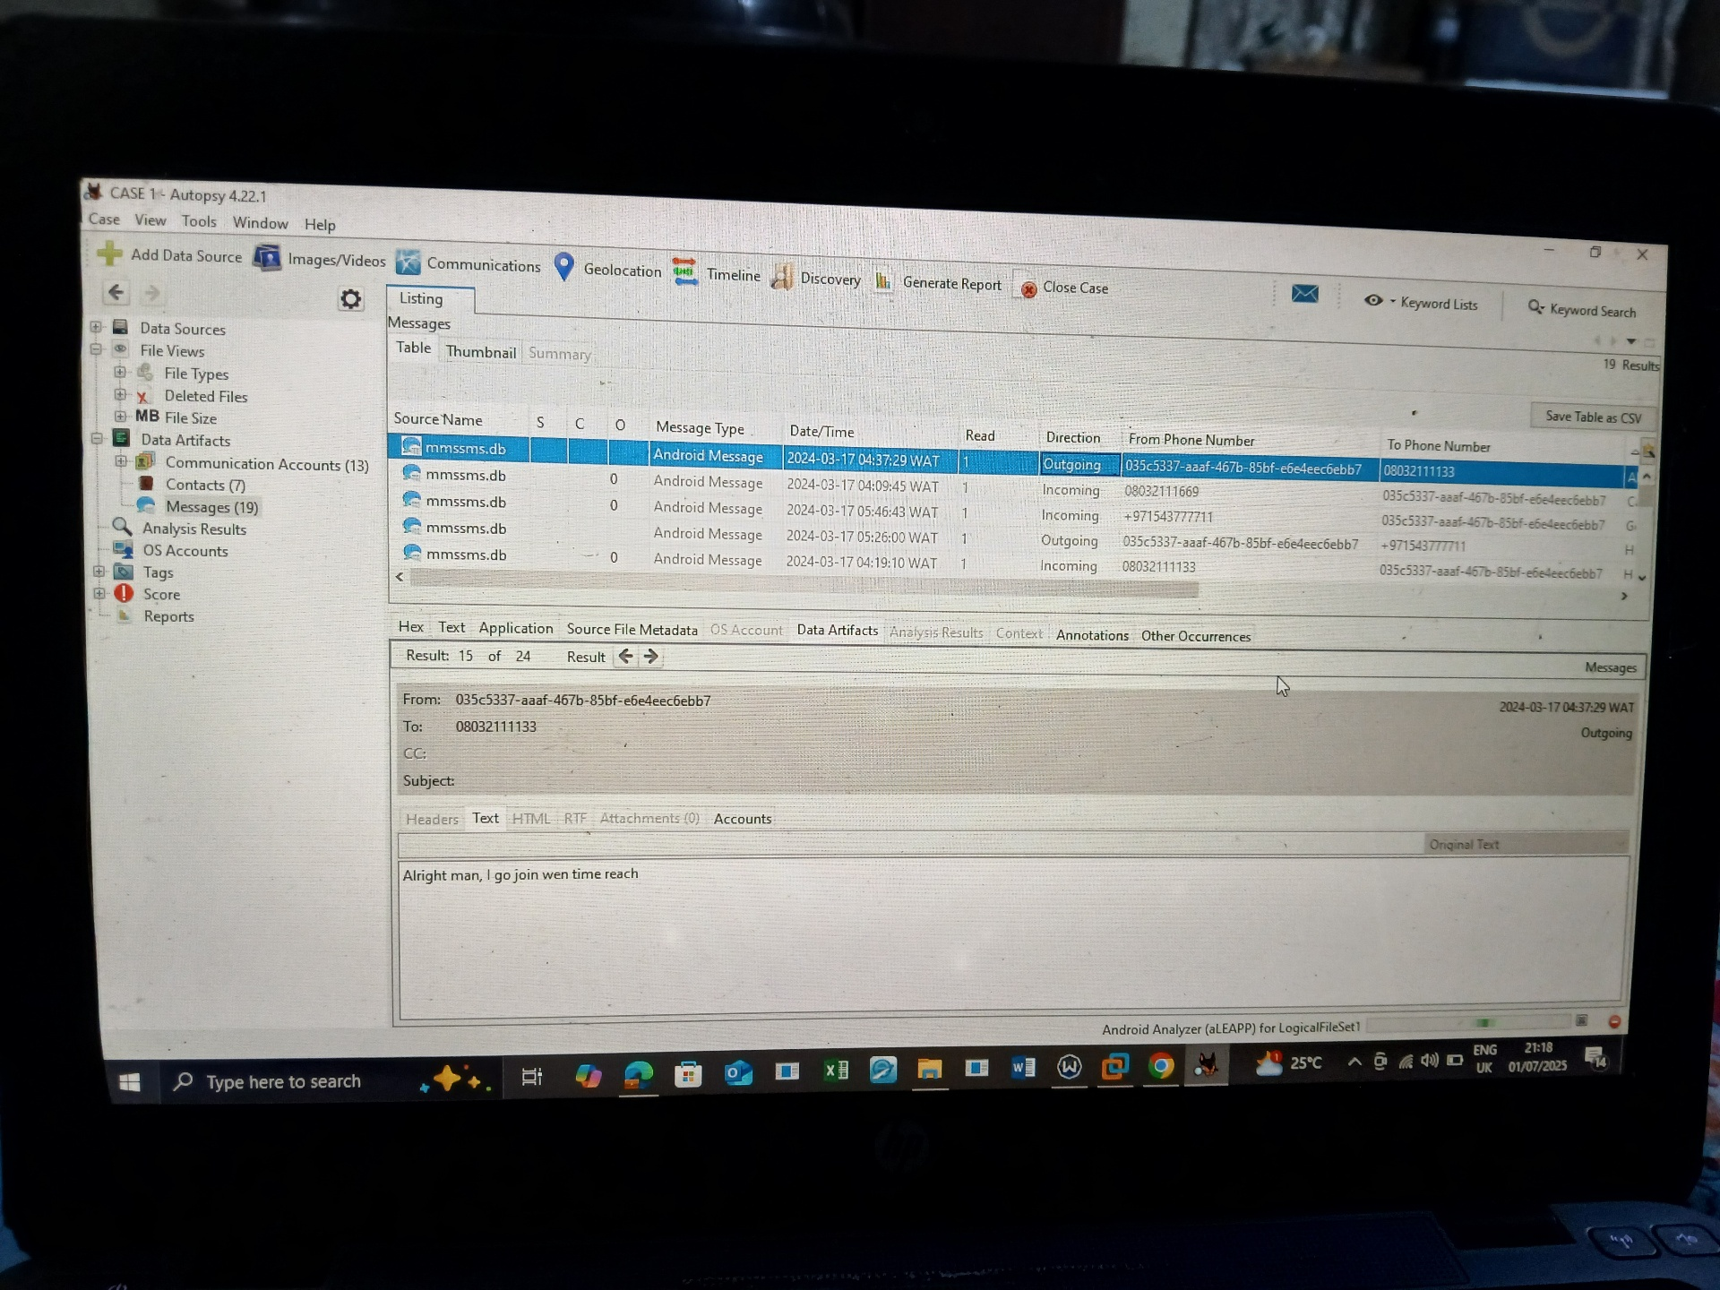

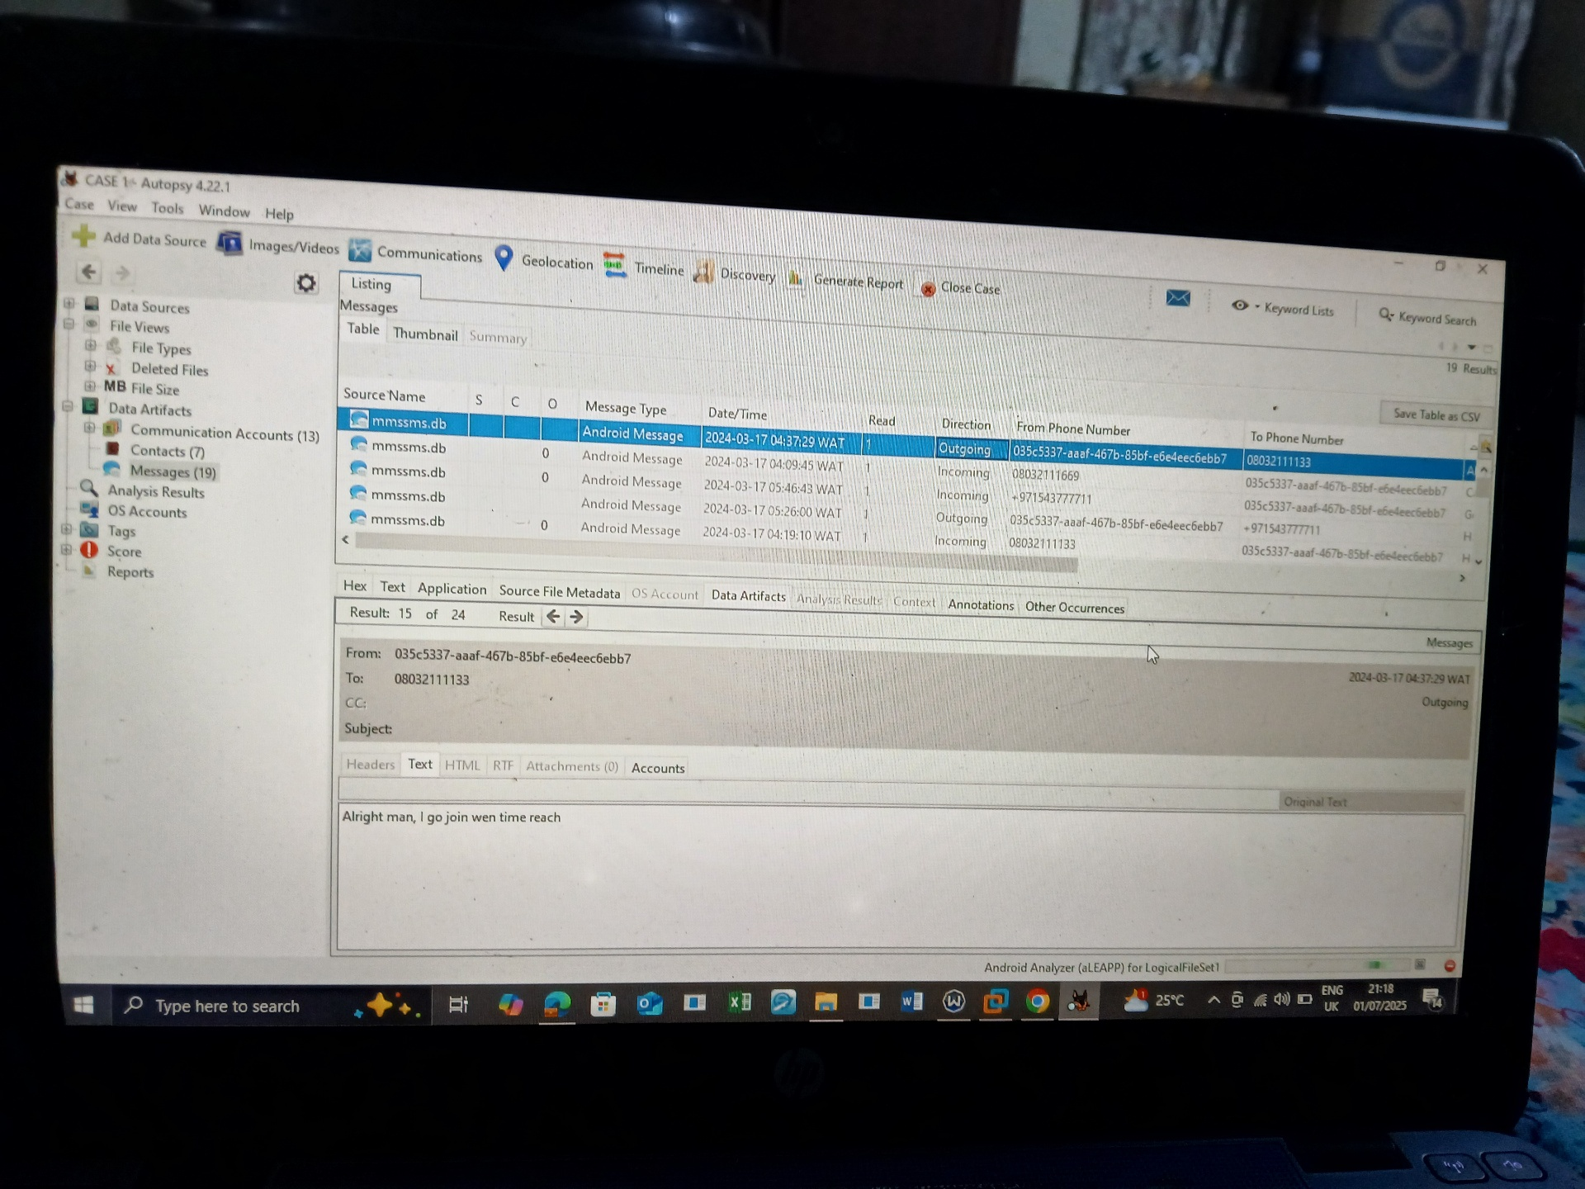

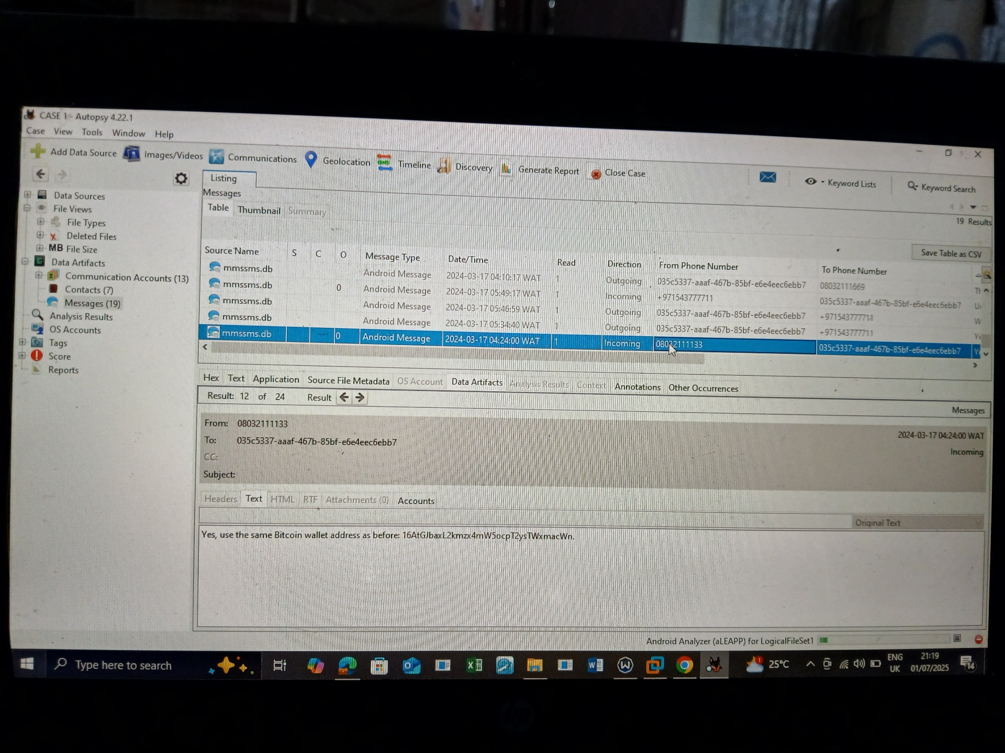

**Extracted Evidence and Key Findings**

Suspicious messages

Browser history

Recent call

The forensic investigation successfully identified and extracted key evidence from the suspect android image

**Recommendations Based on Findings from Android Image Analysis**

Encourage reporting of any strange texts or app behaviors to IT or security teams

Clear browsing history and cache regularly to reduce residual forensic artifacts.

Report malicious links and apps to appropriate cybercrime or threat intelligence organizations.

